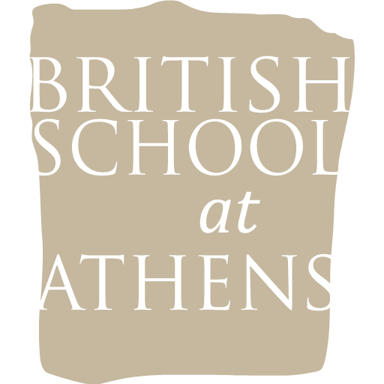
BSA MATERIALS

Application for the Study of the BSA materials
in Greek Museums

Request No.
(office use only)

Name:
Home Address:

Home Telephone:
Email Address:

University:
Address:

I hereby request permission to study the following materials (please include COMPLETE references to the material concerned, plus copies of any illustrations. If publication rights have been assigned, the School requires written permission from the scholar concerned for the study to proceed):

Material:

Purpose of Study:

Intend to publish: Yes No
: Book Article Other

If for PhD or Master’s Degree Bachelor’s Degree
Title:
Name of Supervisor(s):

Previous BSA PERMIT relevant:

I understand that permission to examine materials, if granted, DOES NOT include permission to publish the materials and that a separate written permission to publish must be made to
the British School at Athens specifying such intentions. Please see separate the Publication Request Application.

**Study permissions are granted for 5 years at which time one must reapply to the School for an extension.

NOTE: When an application is approved, the School will issue a letter of permission which should then accompany a formal permit request to the appropriate Greek authorities. Please note that the School’s letter is not in itself a study permit and should not be presented directly at a site or museum. For further information see the Individual Study Permits section or contact the School Administrator.

Printed name: Signature:
Date:

